Biosynthesis of Ethanol from Molasses

**Reference:** “EthanolExpt” Handout; Chemistry lessons: simple and fractional distillation; Green lessons: renewable feedstocks, catalysts, design for degradation; “Distillation” movie

**Purpose:** To distill molasses and make ethanol by using simple and fractional distillation

**Table of Reagents:**

|  |  |  |  |  |  |
| --- | --- | --- | --- | --- | --- |
| **Reagents** | **Amount** | **MW** | **BP (°C)** | **MP (°C)** | **Density** |
| Molasses | 50 mL | 201.22 g/mol | 106.6 °C |  | 1.4 g/cm3 |
| Ca(OH)2 |  | 74.09 g/mol | 2850 °C | 580 °C | 2.21 g/cm3 |
| Yeast | 0.5 g | 274.3 g/mol | 105 °C |  |  |
| Water |  | 18.02 g/mol | 100 °C | 0 °C | 0.997 g/cm3 |

**Balanced Chemical Equation:**

*C12H22O11 (sucrose) 🡪* ***4*** *CH3CH2OH +* ***4*** *CO2*

**Safety:**

* Glass may crack due to high temperature
* Do not distill until dry
* Contains explosive residue (Alkenes/ethers)

|  |  |
| --- | --- |
| **Experimental Procedures** | **Data & Observations** |
| **Part 1: Set up and fermentation**  **1.** Mix 50 mL molasses with 50 mL DI water in 250 mL filter flask. Add 0.5 g yeast and stir! |  |
| **2.** Add rubber stopper to filter flask. Attach rubber hose to side of filter flask and insert short straight section of glass tube to other end of rubber tube. Dip straight glass tube into test tube ~2/3 full of Ca(OH)2 | *Observations:*   * Color of Molasses: Black |
| **3.** Store in drawer until next lab |  |
| **Part 2: Simple Distillation**  **4.** Decant ~50 mL of ethanol solution into 100 mL round bottom flask. Add boiling stone to 100 mL round-bottom flask. |  |
| **5.** Assemble distillation apparatus as shown below. Add water hose and turn water on (gentle trickle). Add thermometer to apparatus and lower the flask into the mantle. |  |
| **6.** Have TA check before plugging in. Wait until thermal equilibrium (boiling point). Collect alcohol fraction until boiling is below of water (100 °C). Record initial boiling point and boiling point after each 2 mL distillation collection.  *** Distillation 🡪 ~2 mL/min *** | *Observations:*   * The molasses boiled over contaminating our collection * The molasses continues to boil and go up the tube |
| **7.** After collection, stop the distillation. Add stopper to flask with ethanol and put back in your drawer until next lab. Clean up and throw away the molasses to the appropriate container. |  |
| **Part 3: Fractional Distillation**  **8.** Assemble fractional distillation apparatus as shown below (simply add in the fractionating column). Have TA check before plugging in. | *Observations:*   * Molasses rising up the fractional tube * Molasses slowly reaching the top of the fractional tube; turned temperature down |
| **9.** Distill mixture slowly and collect several fractions, which are identified by rapid change in temperature. Record temperature range for each fraction. Stop collection below 97 °C. |  |
| **10.** Stop distillation before flask is dry. Temperature can rise rapidly that will result of the flask cracking if no heat absorption is present. |  |
| **11.**  Use volumetric flask 🡪 determine density of each fraction as well as mass and volume of each fraction. $$density=\frac{mass}{volume}$$ |  |

**Post-lab Questions:**

**1.**

**Reaction:** *C12H22O11 (sucrose) 🡪* ***4*** *CH3CH2OH +* ***4*** *CO*

|  |  |  |  |  |  |  |
| --- | --- | --- | --- | --- | --- | --- |
| **Fractions** | **Volume Collected** | **Mass of Collection** | **Density** | **% Ethanol** | **% Yield of EtOH Molasses** | **% Yield of EtOH Sugar** |
| **1** | *1 mL* | *0.856 g* | $$\frac{0.8558 g}{1 mL}$$*0.856 g/mL* | *\*Work in chart\**  *75 %* | $$\frac{0.8558 g*0.5}{8.02 g}×100$$*5.34 %* | $$\frac{0.8558 g*0.5}{8.42 g}×100$$ 5.08 % |
| **2** | *1 mL* | *0.818 g* | $$\frac{0.8176 g}{1 mL}$$*0.818 g/mL* | *\*Work in chart\**  *90 %* | $$\frac{0.8176 g*0.5}{8.02 g}×100$$*5.1 %* | $$\frac{0.8176 g*0.5}{8.42 g}×100$$ 4.86 % |

* 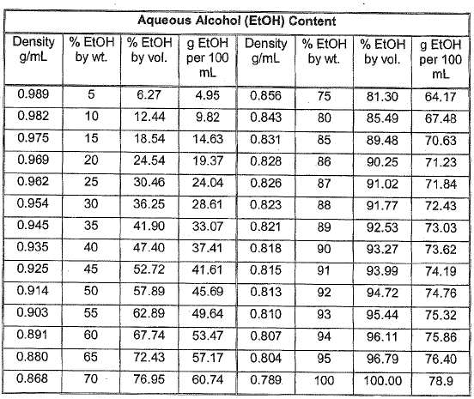**Initial Boiling Point:** *22.1 °C*

Figure . Chart for Calculating % EtOH

* **Temp Ranges:** 
  + *Fraction #1: 68 °C*
  + *Fraction #2: 76.5 °C*

**2.** The advantage of fractional distillation over simple distillation is that fractional distillation can purify liquids better, in a sense that it can separate substances to its respective fractions better. In addition, while the two distillations are similar to each other, the only difference between them is that the fractional distillation has a fractional column attached to it, which allows the liquid to cool down and only let vapor with a low boiling point to travel through.

**3.**  An azeotrope is two substances in a mixture that have a constant boiling point throughout the entire distillation process. In this experiment, 5% of the distillation should be water, which is a result of condensation with the ethanol. The other 95% should be the targeted ethanol we were supposed to make in the distillation. This ratio between water and ethanol is the result of the azeotrope mixture, which lowers the boiling point of the mixture and hinders us from getting the pure ethanol.

**4.** In first setting up our lab, it is critical to prevent air from entering the reaction vessel as this will result in the overoxidation of the ethanol which will turn it to acetic acid.

**5.**  In correspondence to the “greenness” of this experiment, we did not produce any waste which is the first principle of Green Chemistry. All of our substances were able to be thrown down the sink as it was not hazardous to the environment. Furthermore, the substances that we used such as the molasses is renewable material, which corresponds to the 7th Principle in Green Chemistry. Molasses, which we used to distill and gather the ethanol from is renewable in a sense that it is the byproduct of the processed sugar and not anything depletable such as fossil fuel. Finally, we did not incorporate any hazardous chemicals in our experiment that would be toxic to us or the environment, since our main ingredient was molasses.